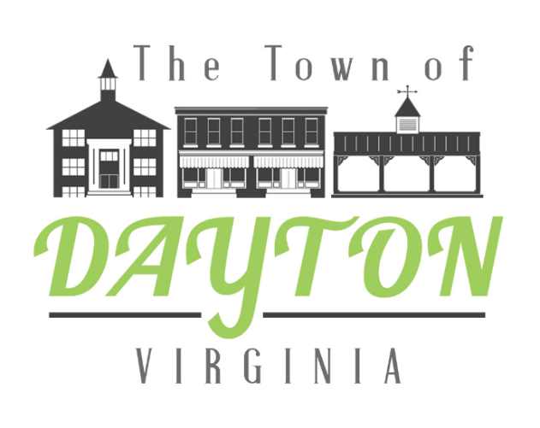

REGULAR COUNCIL MEETING

AGENDA

Council Chambers, Dayton Municipal Building

January 8, 2018

AGENDA ITEMS
1 – CALL TO ORDER, INVOCATION, PLEDGE OF ALLEGIANCE
2 – ADOPTION OF AGENDA
3 – PUBLIC HEARING

4 – SUPERINTENDENT’S REPORT
5 – STAFF & COMMITTEE REPORTS (Treasurer, Police, Sewer Authority, Planning Commission, Finance, Personnel, Economic Development, Parks & Community Development, Annexation, Grants, Muddler)
6 – ACTION MATTERS
Approval of Bills

7 – PRESENTATIONS (normally not to exceed 10 minutes each)

8 – CONSENT AGENDA
Minutes of the December 11, 2017 Meeting

9 – UNFINISHED BUSINESS
Board of Zoning Appeals Recommendation to the Circuit Court to fill Vacancy

10 – NEW BUSINESS

11 – PUBLIC COMMENT
12 – MAYOR AND COUNCIL COMMENTS
13 - CLOSED SESSION

14 – ADJORN

